PROJECT 3

1.Prepare Heat Map for state wise Owned/leased houses of year 2014. Keep filter option for ender user to selected Owned or leased. Please refer image-1.

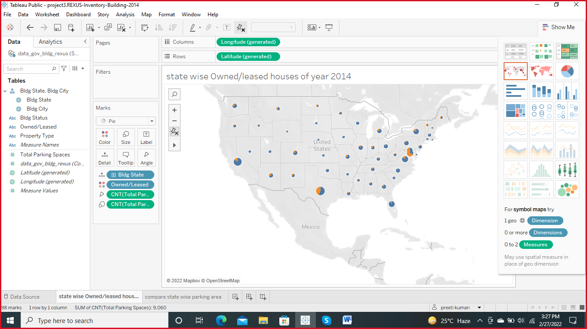

1. Prepare column chart to compare state wise parking area for each property type. Please refer image-2.

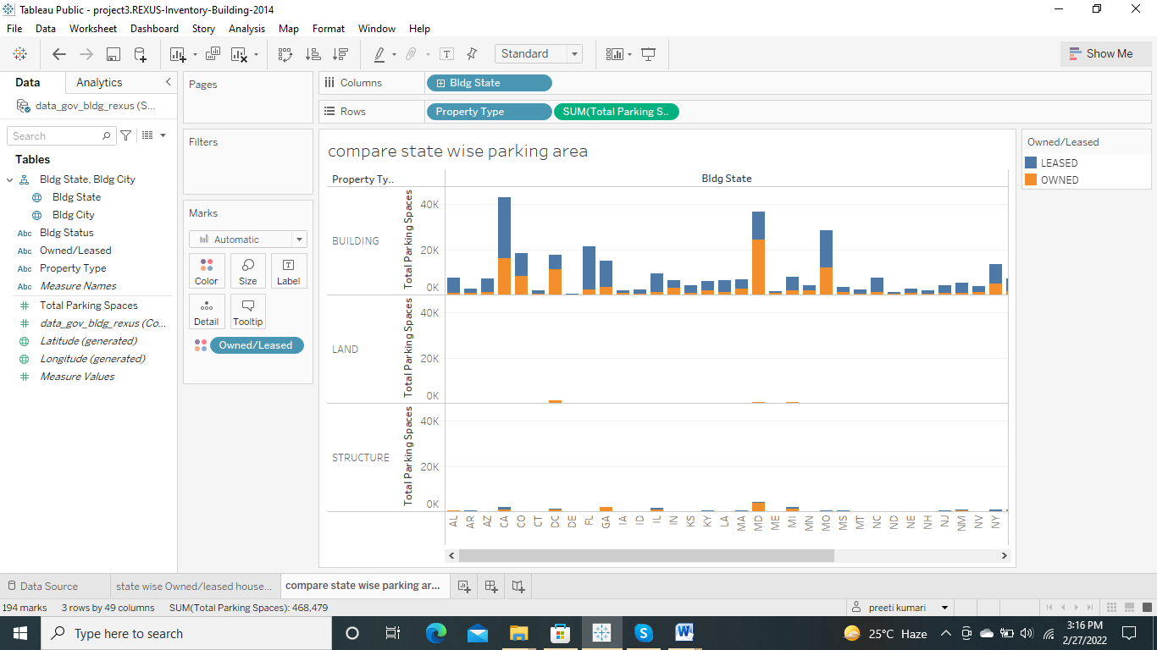

1. Prepare dashboard to display both reports together. Keep filter option based on owned/lease column for end user. Also make send report to be used as filter options.

